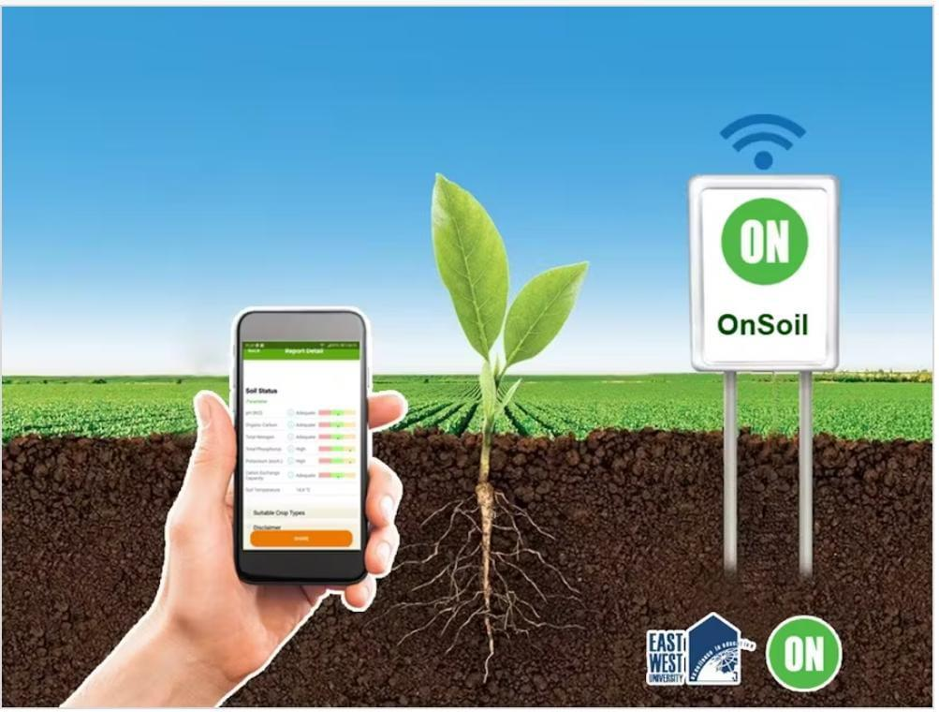

Smart Plant Monitoring System

MADE BY:-  **Debasis Maharana 22BECC93**

**Aayushi Samantsinghar 22BEIF18**

**Nagen Bihari 22BECG53**

**Premanshu Dash 21BEEC27**

**Jyoti Prakash Behera 23BEEG12**

# CONTENT

# **Project Summary**

# **Key features**

# **Hardware used and its specifications**

# **About Rightech Cloud**

# **Software Requirement**

# **System Architecture**

# **Working Principle of the Model Application**

# **Circuit Connection**

# **Code Snippet**

# **Project Interfacing in Rightech Cloud**

# **Future Enhancement**

# **Conclusion**

Project Summary

The Smart Plant Monitoring System is a compact and intelligent IoT-based solution that automates plant care using the Rugged Board A5D2X integrated with a WE-10 Wi-Fi module for real-time monitoring and cloud connectivity. The system utilizes multiple sensors and actuators to maintain optimal plant health. The HW103 soil moisture sensor detects the soil's water content, while the AHT25 sensor monitors ambient temperature and humidity. The LDR module measures sunlight intensity, and a servo motor operates a protective cover to shield the plant from excessive light when needed. When soil moisture is low and the environmental conditions (temperature and humidity) are unfavorable, a relay module automatically triggers a 12V water pump to irrigate the plant. All sensor readings are transmitted via Wi-Fi to a cloud platform, enabling remote access and real-time updates. The entire system is powered by a 12V supply and built using supporting components like resistors, breadboards, and connecting wires. This smart solution promotes automation, water conservation, and healthier plant growth, making it ideal for smart agriculture, home gardening, and educational projects.

🌿 Features of Smart Plant Monitoring System :-

1. Real-Time Environmental Monitoring :-   
    Continuously tracks soil moisture, temperature, humidity, and light intensity.
2. Automatic Irrigation Control :-   
    Activates the water pump automatically when soil moisture is low and temperature/humidity are high.
3. Sunlight Protection Mechanism :-   
    Uses a servo motor to move a shade and protect plants from excessive sunlight.
4. Wi-Fi Enabled Cloud Connectivity :-   
    Sends sensor data to the cloud via the WE10 Wi-Fi module for remote access and monitoring.
5. Smart Decision Making :-   
    Uses sensor thresholds and conditional logic for automated actions, reducing manual intervention.
6. Energy Efficient Design :-   
    Operates on a 12V power supply with minimal energy consumption.
7. Modular and Scalable :-   
    Easily extendable with additional sensors or plant units for larger setups.
8. User Alerts and Dashboard (Optional Feature):-   
    Can be integrated with dashboards or apps to alert users about critical conditions (like dry soil or high heat).
9. Compact and Cost-Effective :-   
    Built using affordable components, making it ideal for students, farmers, or smart home gardens.
10. Educational and Practical Application :-   
     Great for learning embedded systems, IoT, and real-world automation in agriculture.

🔧 Hardware Components and its specification :-

# Rugged Board A5D2X :-

The rugged board is a powerful embedded system with high durability and reliability, suitable for operating in harsh environments. It serves as the main processing unit for data acquisition, analysis, and communication. Its robust design allows it to operate reliably in harsh environments. Rugged boards are built with high-quality materials and advanced manufacturing processes to ensure durability and resistance to physical damage.They can operate over a wide temperature range, from extremely cold to high-temperature conditions, without performance degradation. They are designed for long-term deployment, reducing the need for frequent replacements and minimizing maintenance costs.

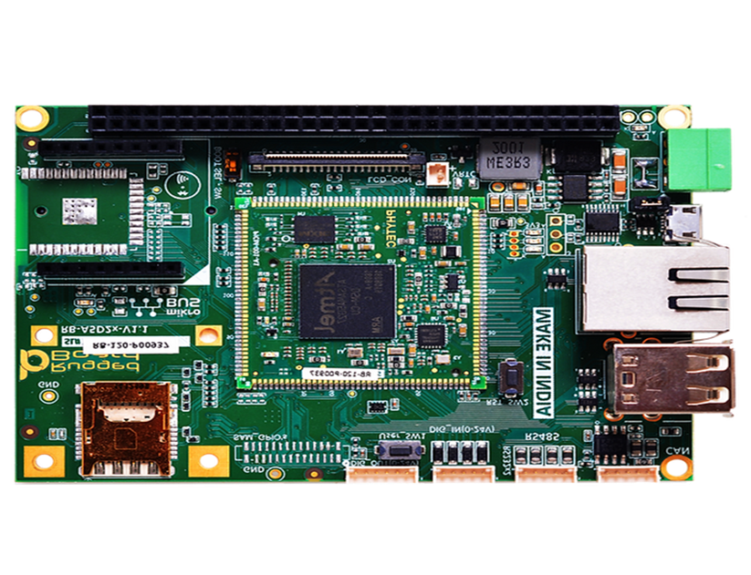

# WE-10 Wireless Module :-

The WE10 wireless module facilitates communication between the rugged board and various sensors. It supports various wireless protools, enabling seamless data transmission.The WE10 acts as the main controller and data processor.The WE10 serves as the main control unit of the environment monitoring system. It is equipped with a powerful ARM-based processor and various I/O interfaces, making it capable of handling sensor data and executing complex tasks.The WE10 communicates with the AHT25 sensor to retrieve temperature and humidity data at regular intervals.The WE10 can be equipped with various wireless communication modules, such as Wi-Fi, Bluetooth, or LoRa, to enable real-time data transmission to a central server, cloud platform, or a user interface for remote monitoring and analysis.The WE10 efficiently manages power consumption to prolong battery life in off-grid applications or to ensure stable operation in areas with unreliable power sources.The wireless module might be capable of storing sensor data locally or transmitting it to a remote server for later analysis and retrieval.It is configured to transmit the collected temperature and humidity data to a central server or user device. The WE10 WiFi Module plays a vital role in enabling wireless communication between the rugged board and the AHT25 Sensor. It supports WiFi connectivity, allowing data transmission over a local network or the internet. With wireless capabilities, the system becomes more versatile and can be deployed in remote or hard-to-reach locations without the need for extensive wiring.

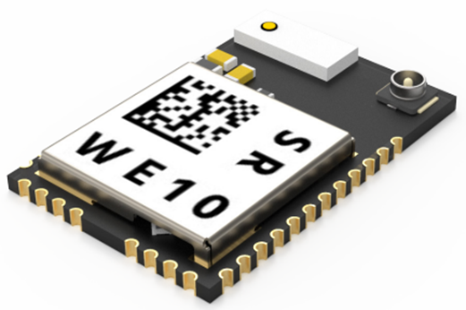

# Soil moisture Sensor (HW080) :-

The HW-080 Soil Moisture Sensor is a capacitive-type sensor used to detect the water content in soil with greater accuracy and durability compared to traditional resistive sensors like the HW-103. It operates by measuring changes in capacitance to determine soil moisture levels, without having exposed metal electrodes, making it highly resistant to corrosion and ideal for long-term use in plant monitoring systems. The sensor provides an analog voltage output, where the voltage decreases as the moisture level increases—wet soil gives lower output, while dry soil results in higher voltage. It typically works within a voltage range of 3.3V to 5V, making it fully compatible with the Rugged Board A5D2X. The analog signal from the sensor is read by the ADC (Analog-to-Digital Converter) pin on the board, allowing the system to make intelligent irrigation decisions. Its stable and consistent readings, longer lifespan, and low maintenance requirements make HW-108 a preferred choice for smart agriculture and automated plant care applications.

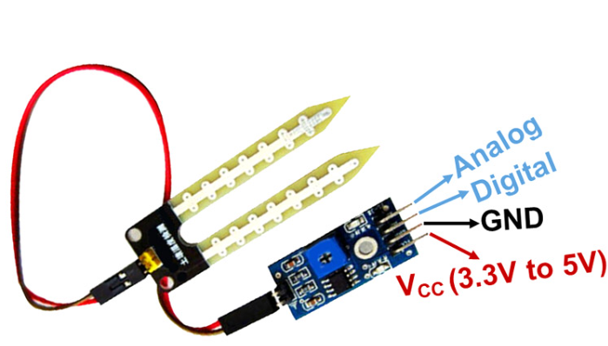

# AHT25 Sensor ( Temperature and Humidity ) :-

The AHT25 can be widely used in consumer electronics, medical, automotive, industrial, meteorological and other fields, such as: HVAC, dehumidifiers and refrigerators and other home appliances, testing and testing equipment and other related temperature and humidity testing and control product.The high-precision AHT25 sensor measures essential environmental parameters such as temperature, humidity, pressure, and air quality. Its accuracy ensures that the collected data is reliable and of high quality. Monitors environmental parameters and sends data to the rugged board through the WE10 module.The AHT25 sensor is interfaced with the rugged board through [Specify the communication interface used, e.g., I2C]. The rugged board continuously reads temperature and humidity data from the AHT25 sensor.It utilizes built-in temperature sensing elements to detect and convert the temperature of the surrounding environment into electrical signals.The AHT25 sensor provides digital output, which makes it easy to interface with microcontrollers and processing units like the rugged board used in the project. The digital interface simplifies data acquisition and processing.The AHT25 sensor is designed to consume low power, which is beneficial for battery-operated systems.

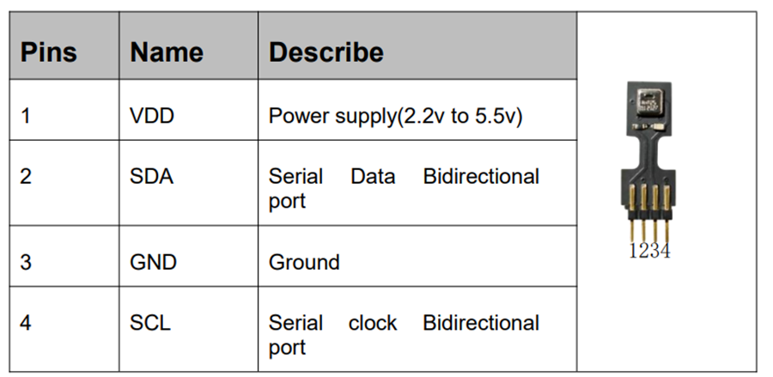

# Water Pump :-

The Water Pump is a crucial actuator in the Smart Plant Monitoring System, responsible for automatically watering the plant based on real-time soil conditions. It operates on a 12V DC supply and is controlled by a relay module connected to the Rugged Board A5D2X. When the system detects low soil moisture levels—especially under high temperature and low humidity conditions—the board triggers the relay, which then powers the pump to irrigate the plant. This automation helps prevent both overwatering and underwatering, ensuring the plant receives water only when necessary. The use of a small submersible or diaphragm pump makes the system compact, energy-efficient, and easy to install in indoor or outdoor setups. This intelligent integration of sensor data and automated watering reduces manual effort and supports sustainable and efficient water usage, making the pump an essential element in smart irrigation systems.

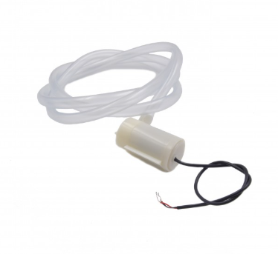

# Relay Module :-

The Relay Module serves as a key interface between the low-power control signals from the Rugged Board A5D2X and high-power devices like the 12V water pump. It acts as an electronic switch that allows the microcontroller to safely control high-voltage or high-current devices without direct electrical connection. When the soil moisture is low and environmental conditions such as temperature and humidity reach critical levels, the board sends a digital signal to the relay, which then activates the water pump to irrigate the plant. The relay provides isolation, safety, and control flexibility, making it an essential component for automating the irrigation process. With its onboard indicator LED and optocoupler protection, the relay module is reliable, easy to use, and ideal for switching operations in plant monitoring and other IoT automation systems.

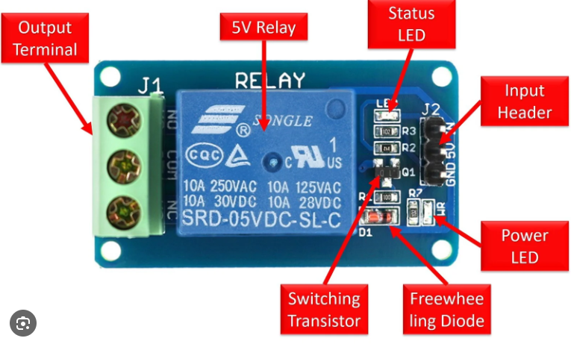

# Servo Motor :-

The Servo Motor in the Smart Plant Monitoring System is used to mechanically control a shade or cover that protects the plant from excessive sunlight. Controlled by the Rugged Board A5D2X, the servo receives PWM (Pulse Width Modulation) signals to precisely rotate to a specified angle, usually between 0° and 180°. When the LDR module detects high light intensity beyond a defined threshold, the board commands the servo motor to adjust the position of a shield or curtain, thereby reducing sunlight exposure to prevent plant damage. Servo motors are preferred in such applications because of their high accuracy, low power consumption, and easy controllability through microcontroller signals. Compact in size and lightweight, the servo motor is an ideal actuator for dynamic, real-time control tasks in smart agriculture and environmental automation systems.

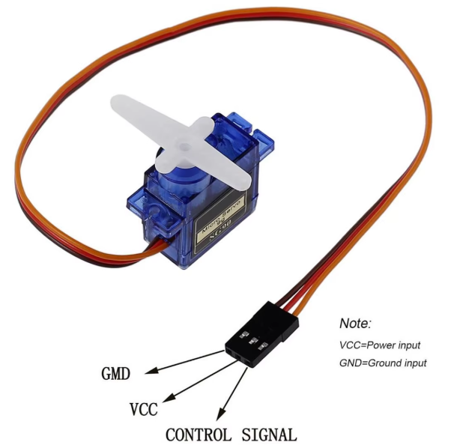

Rightech Cloud :-

Rightech Cloud is a flexible and developer-friendly IoT cloud platform designed to connect, monitor, and manage IoT devices and data in real time. In the Smart Plant Monitoring System, Rightech Cloud enables seamless data visualization, remote monitoring, and control of environmental parameters such as soil moisture, temperature, humidity, and light intensity. Using the WE10 Wi-Fi module, the Rugged Board A5D2X sends sensor data to Rightech Cloud, where it can be displayed on dashboards, stored for analysis, and used to trigger alerts or automation rules. The platform supports device simulation, API integration, rule-based logic, and real-time data streaming, making it ideal for IoT developers and students. With its user-friendly interface and free tier options, Rightech Cloud empowers users to prototype, test, and scale IoT solutions efficiently—helping turn raw sensor data into actionable insights for smarter agriculture and plant care systems.

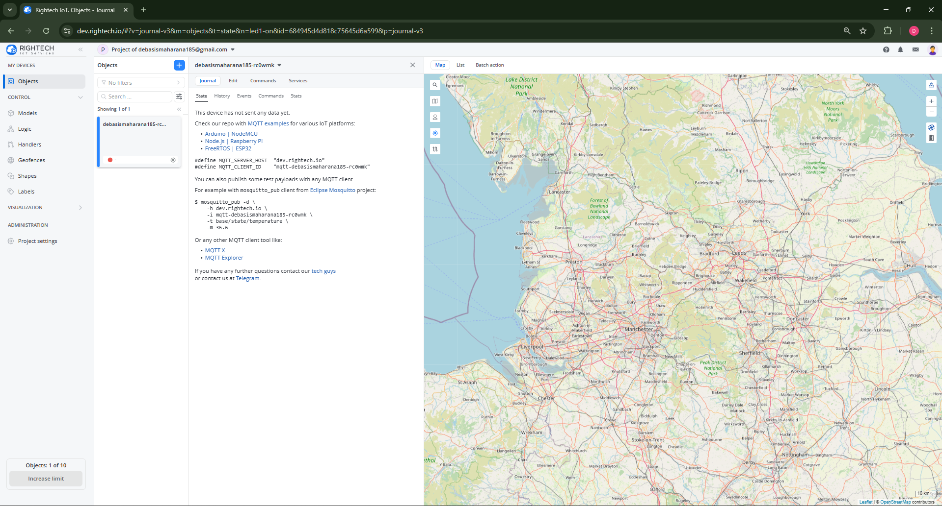

💻 Software Requirements:-

1. **Embedded Linux** (running on Rugged Board)
2. **C Language** (for sensor interfacing)
3. **MQTT or HTTP** (for IoT cloud interface, optional)
4. **Rightech Cloud** ( for showing the data )

🔁 System Architecture: -

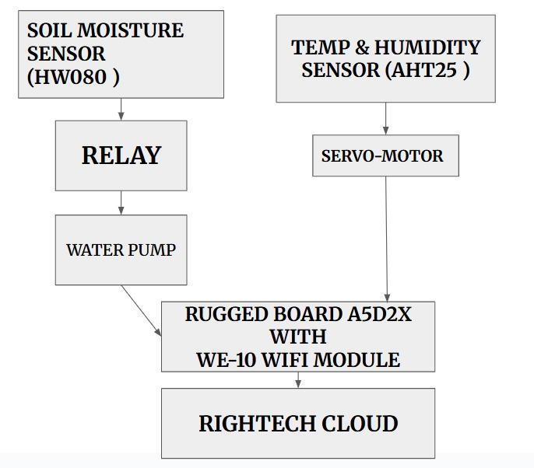

⚙️ Working Principle:-

* 1. **Sensors Collect Data**:-
  + **Soil Moisture**: Detects dryness.
  + **Temperature/Humidity (AHT25)**: Monitors ambient climate.
  + **Light (LDR)**: Detects light level.
  1. **Processing on Rugged Board**:-
  + If soil is dry and no rain is detected, the pump is activated.
  + pH level is monitored and logged to indicate if the soil needs treatment.
  + Data is stored locally and displayed via a web dashboard.
  1. **Output & Actuation**:-
  + Pump control via relay.
  + Live sensor display on web or screen.
  + Optional cloud integration for remote monitoring.

Circuit Connection:-

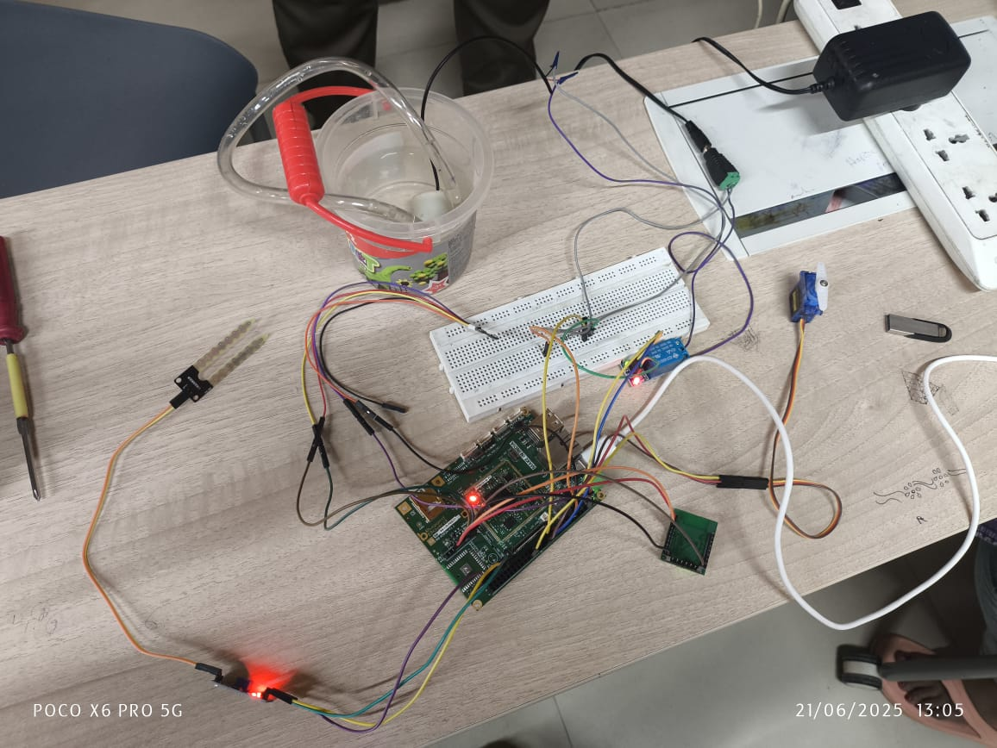

Code Snippet:-

# Code Snippet For AHT25:-

void aht25_init() {

    uint8_t init_cmd[3] = {0xBE, 0x08, 0x00};

    mraa_i2c_write(i2c, (char*)init_cmd, 3);

    usleep(10000);

}

int aht25_read(float* temperature, float* humidity) {

    uint8_t cmd[3] = {0xAC, 0x33, 0x00};

    mraa_i2c_write(i2c, (char*)cmd, 3);

    usleep(80000);

    uint8_t data[6];

    if (mraa_i2c_read(i2c, (char*)data, 6) != 6) return -1;

    if ((data[0] & 0x80) != 0) return -2;

    uint32_t raw_h = ((uint32_t)data[1] << 12) | ((uint32_t)data[2] << 4) | ((data[3] & 0xF0) >> 4);

    uint32_t raw_t = ((uint32_t)(data[3] & 0x0F) << 16) | ((uint32_t)data[4] << 8) | data[5];

    *humidity = ((float)raw_h * 100) / 1048576.0;

    *temperature = ((float)raw_t * 200 / 1048576.0) - 50;

    return 0;

}

# Code Snippet For ServoMotor:-

void move_servo_soft_pwm(float angle) {

    if (angle < 0) angle = 0;

    if (angle > 270) angle = 270;

    float pulse_ms = 1.0 + (angle / 270.0);

    int pulse_high_us = (int)(pulse_ms * 1000);

    int period_us = 20000;

    for (int i = 0; i < 5; ++i) {

        mraa_gpio_write(servo_gpio, 1);

        usleep(pulse_high_us);

        mraa_gpio_write(servo_gpio, 0);

        usleep(period_us - pulse_high_us);

    }

}

# Code Snippet For Soil Moisture(HW080):-

void read_soil_moisture(uint16_t* value) {

    *value = mraa_aio_read(adc_soil);

    printf("Soil Moisture: %u\n", *value);

}

void control_pump_by_soil(uint16_t soil_val) {

    if (soil_val > 700) {

        mraa_gpio_write(relay_gpio, 1);

        printf("Pump ON (Dry Soil)\n");

    }

else {

        mraa_gpio_write(relay_gpio, 0);

        printf("Pump OFF (Wet Soil)\n");

    }

}

# Code Snippet For WE10:-

void WE10_Init() {

    const char* cmd;

    cmd = "CMD+RESET\r\n";

    mraa_uart_write(uart, cmd, strlen(cmd));

    sleep(1);

    cmd = "CMD+WIFIMODE=1\r\n";

    mraa_uart_write(uart, cmd, strlen(cmd));

    sleep(1);

    cmd = "CMD+CONTOAP=\"Aayu\",\"byee1234\"\r\n";  // Replace with your WiFi credentials

    mraa_uart_write(uart, cmd, strlen(cmd));

    sleep(5);

    cmd = "CMD?WIFI\r\n";

    mraa_uart_write(uart, cmd, strlen(cmd));

    sleep(1);

}

# Code Snippet For MQTT:-

void MQTT_Init() {

    const char* cmd;

    cmd = "CMD+MQTTNETCFG=dev.rightech.io,1883\r\n";

    mraa_uart_write(uart, cmd, strlen(cmd));

    sleep(1);

    cmd = "CMD+MQTTCONCFG=3,mqtt-aayushisamantsinghar21-jg90p8,,,,,,,,,\r\n";

    mraa_uart_write(uart, cmd, strlen(cmd));

    sleep(1);

    cmd = "CMD+MQTTSTART=1\r\n";

    mraa_uart_write(uart, cmd, strlen(cmd));

    sleep(1);

}

void MQTT_Publish(const char* topic, const char* message) {

    char cmd[256];

    snprintf(cmd, sizeof(cmd), "CMD+MQTTPUB=%s,%s\r\n", topic, message);

mraa_uart_write(uart, cmd, strlen(cmd));

    usleep(200000);

}

# Code Snippet :-

#include <stdio.h>

#include <stdlib.h>

#include <stdint.h>

#include <unistd.h>

#include <string.h>

#include <mraa.h>

#include <mraa/uart.h>

#define ADC_SOIL_PIN        6

#define RELAY_PIN           14

#define SERVO_GPIO_PIN      37

#define AHT25_I2C_BUS       1

#define AHT25_ADDR          0x38

#define UART_DEVICE         "/dev/ttyS3"

mraa_gpio_context relay_gpio;

mraa_gpio_context servo_gpio;

mraa_aio_context adc_soil;

mraa_i2c_context i2c;

mraa_uart_context uart;

void init_peripherals();

void aht25_init();

int aht25_read(float* temperature, float* humidity);

void move_servo_soft_pwm(float angle);

void read_soil_moisture(uint16_t* value);

void control_pump_by_soil(uint16_t soil_val);

void WE10_Init();

void MQTT_Init();

void MQTT_Publish(const char* topic, const char* message);

void cleanup();

void init_peripherals() {

    mraa_init();

    relay_gpio = mraa_gpio_init(RELAY_PIN);

    mraa_gpio_dir(relay_gpio, MRAA_GPIO_OUT);

    servo_gpio = mraa_gpio_init(SERVO_GPIO_PIN);

    mraa_gpio_dir(servo_gpio, MRAA_GPIO_OUT);

    adc_soil = mraa_aio_init(ADC_SOIL_PIN);

    i2c = mraa_i2c_init(AHT25_I2C_BUS);

    mraa_i2c_address(i2c, AHT25_ADDR);

    aht25_init();

   uart = mraa_uart_init_raw(UART_DEVICE);

    mraa_uart_set_baudrate(uart, 38400);

    mraa_uart_set_mode(uart, 8, MRAA_UART_PARITY_NONE, 1);

    if (!relay_gpio || !servo_gpio || !adc_soil || !i2c || !uart) {

        fprintf(stderr, "Peripheral initialization failed\n");

        exit(1);

    }

}

void cleanup() {

    mraa_gpio_close(relay_gpio);

    mraa_gpio_close(servo_gpio);

    mraa_aio_close(adc_soil);

    mraa_i2c_stop(i2c);

    mraa_uart_stop(uart);

    mraa_deinit();

}

int main() {

    init_peripherals();

    WE10_Init();

    MQTT_Init();

    while (1) {

        float temp = 0.0, hum = 0.0;

        uint16_t soil_value = 0;

        if (aht25_read(&temp, &hum) == 0) {

            printf("Temp: %.2f°C | Hum: %.2f%%\n", temp, hum);

            if (temp >= 30.0) {

                move_servo_soft_pwm(180.0);

            } else {

                move_servo_soft_pwm(0.0);

            }

            char temp_str[32], hum_str[32];

            snprintf(temp_str, sizeof(temp_str), "%.2f", temp);

            snprintf(hum_str, sizeof(hum_str), "%.2f", hum);

            MQTT_Publish("base/sensor/temp", temp_str);

            MQTT_Publish("base/sensor/hum", hum_str);

        }

        read_soil_moisture(&soil_value);

        control_pump_by_soil(soil_value);

        char soil_str[16];

        snprintf(soil_str, sizeof(soil_str), "%u", soil_value);

        MQTT_Publish("base/sensor/soil", soil_str);

        sleep(1);

    }

    cleanup();

    return 0;

}

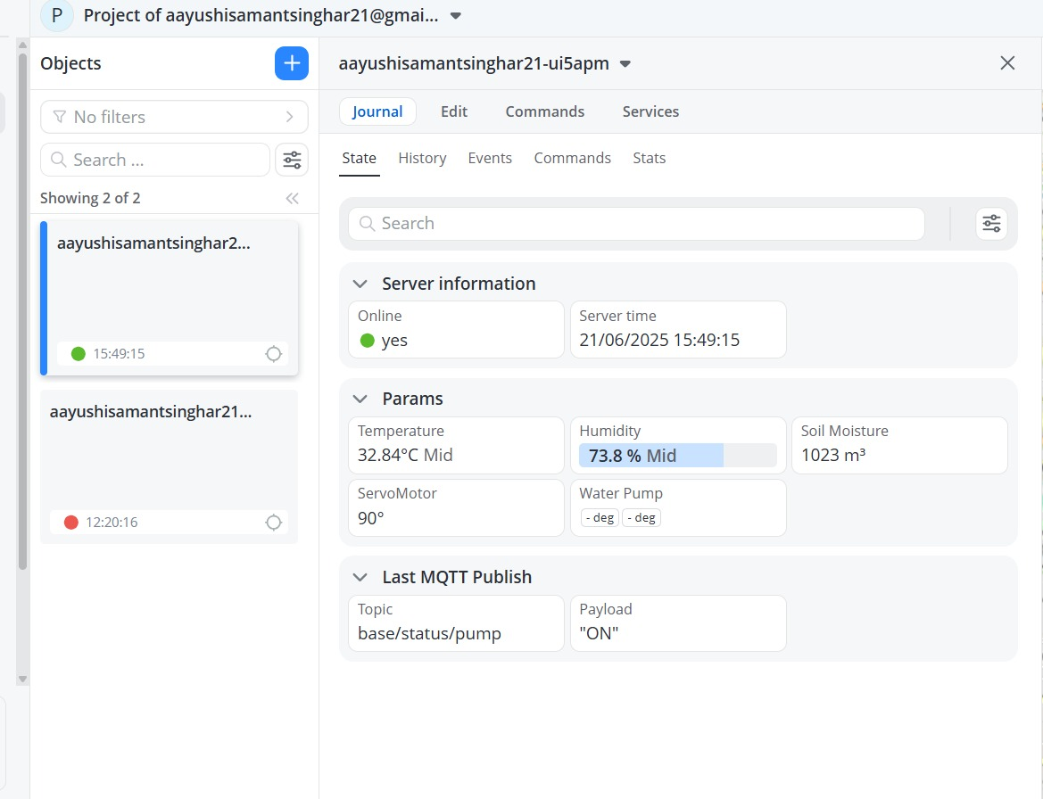



🌱 Future Enhancements:

To further improve the system’s capabilities and broaden its applications, several advanced features can be introduced. One significant enhancement is the integration of a camera module for image-based plant health analysis. With this, the system can monitor crops visually and use machine learning algorithms to detect early signs of diseases, pest attacks, or nutrient deficiencies by analyzing leaf color, texture, and patterns. This approach allows for precise, data-driven decision-making and reduces the need for manual inspection. Another key improvement is the addition of a solar panel to power the system. This would make the setup self-sustained, energy-efficient, and suitable for deployment in remote areas without relying on grid electricity.

In addition, a mobile application can be developed to provide users with real-time access to environmental data, system status, and historical trends. This app would also enable remote control of irrigation, lighting, and other actuators, making the system more accessible and user-friendly. For added convenience, voice assistant integration—such as with Amazon Alexa or Google Assistant—can be included to allow hands-free interaction. Users could simply speak commands to check soil moisture levels, activate irrigation, or receive system updates. Furthermore, to ensure reliable long-distance communication, especially in large or rural farms, LoRa (Long Range) technology can be implemented. LoRa enables low-power, long-range wireless communication, making the system highly efficient for widespread agricultural use.

Conclusion:-

The proposed system offers a robust foundation for modern, technology-driven agriculture. With its core applications in smart farming, indoor gardening, greenhouse automation, and crop behavior research, it provides a comprehensive solution to many of the challenges faced in traditional agriculture. The inclusion of advanced sensors and automation tools already enhances efficiency, but the future upgrades will significantly elevate its potential. Features like AI-powered plant health analysis, solar-based self-sustaining operation, mobile and voice-enabled control, and long-range connectivity using LoRa will make the system more intelligent, autonomous, and scalable.

These enhancements not only promise better resource management and increased productivity but also make the technology more accessible to farmers across different regions and scales of operation. As agriculture moves toward sustainability and precision-based practices, such a smart monitoring and control system will play a crucial role. It will empower farmers with real-time insights, reduce environmental impact, and support food security by ensuring healthier crops and optimized growth conditions. Overall, this innovation paves the way for a greener, smarter, and more resilient future in agriculture.